**MODEL BUILDING**

**SAVE THE MODEL**

|  |  |
| --- | --- |
| Team ID | PNT2022TMID14000 |
| Project Name | Project-Emerging methods for early detection of forest fires |
|  |  |

**SAVE THE MODEL**

Your model is to be saved for future purposes. This saved model also is integrated with an android application or web application in order to predict something.

**IMPORT LIBRARIES:**

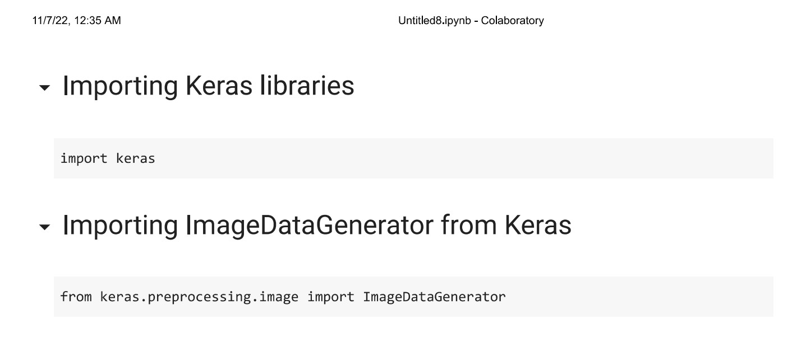

**IMPORT ImageDataGenerator FROM KERAS:**

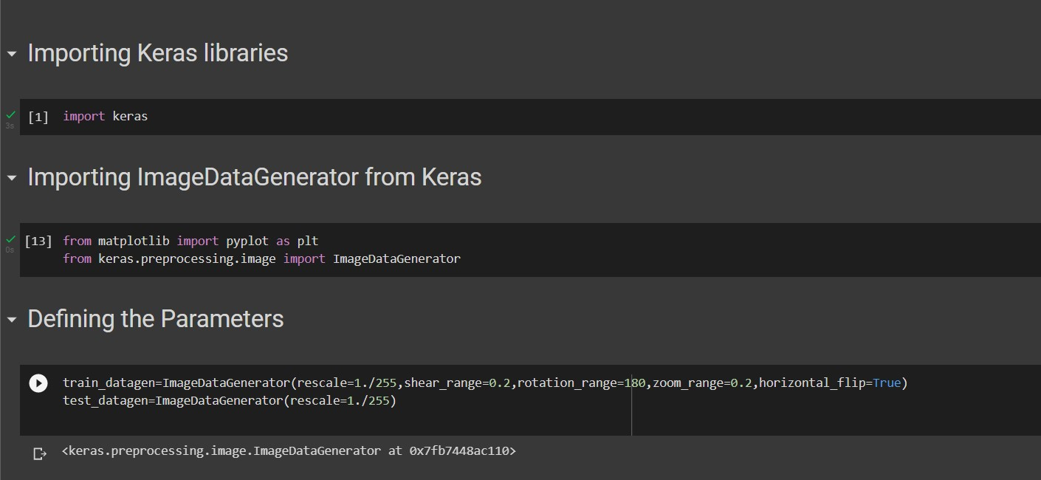

**APPLYING ImageDataGenerator to train dataset:**

ply**flow_from_directory ( )**methodfor Train folder.

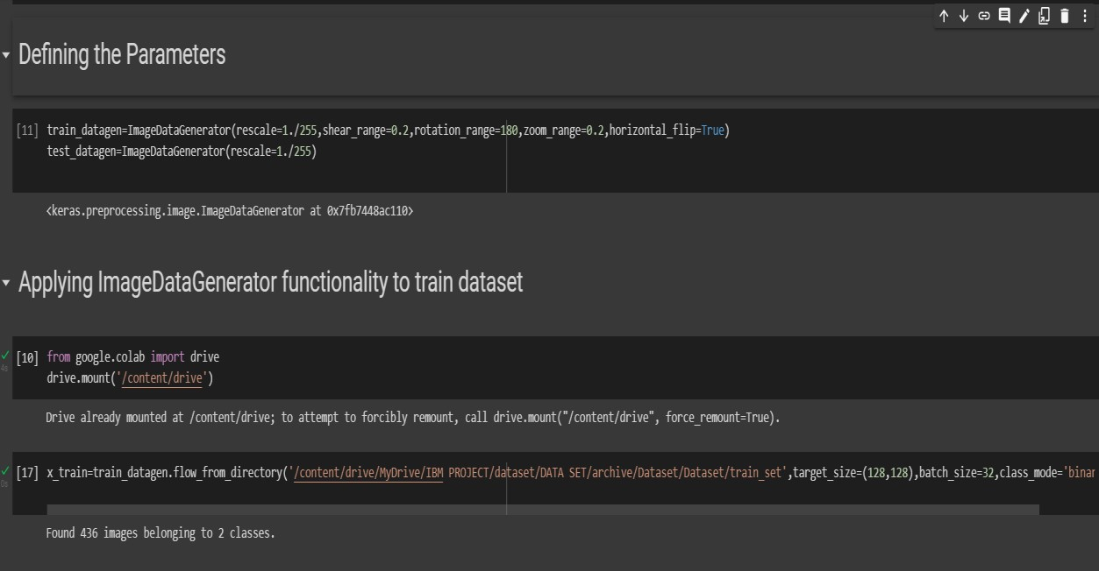

**APPLYING ImageDataGenerator to test dataset:**

Applying the **flow_from_directory ( )** methodfortest folder.

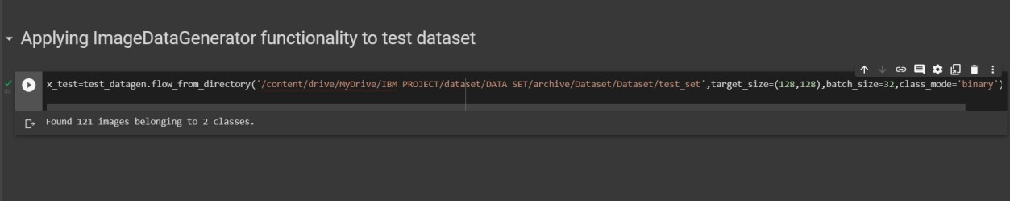

**IMPORTING MODEL BUILDING LIBRARIES:**

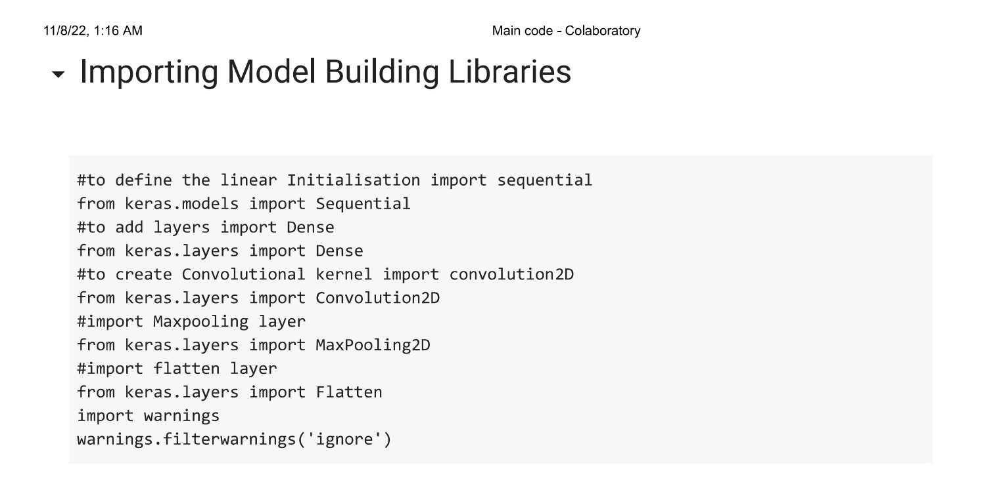

**INITIALIZING THE MODEL:**

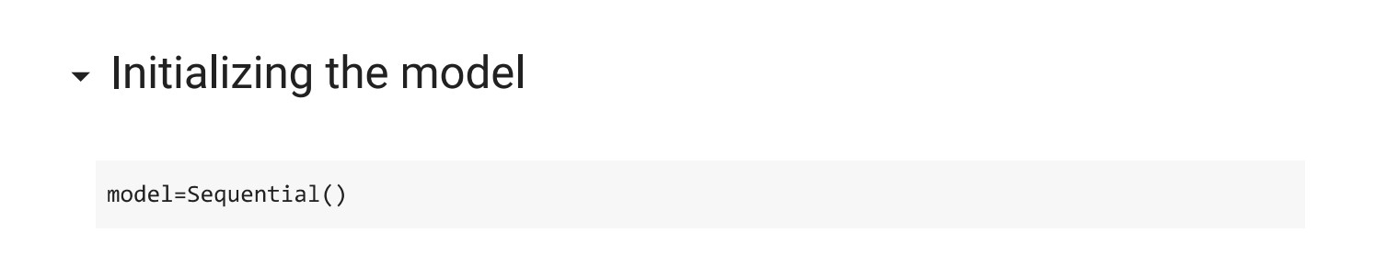

**ADDING CNN LAYERS:**

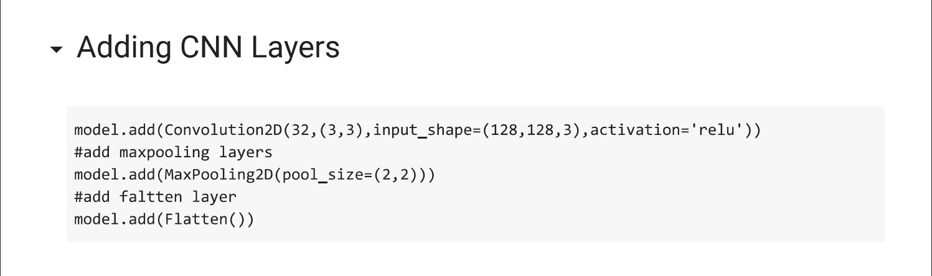

**ADDING DENSE LAYERS:**

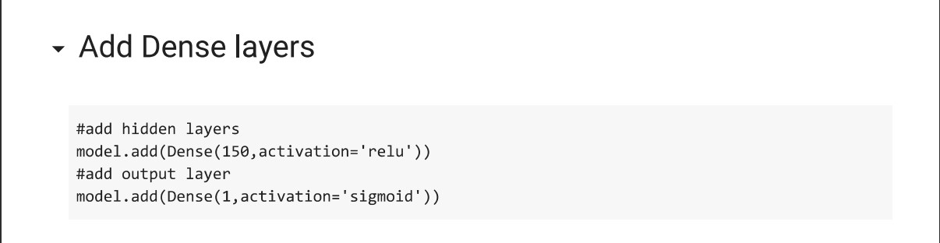

**CONFIGURING THE LEARNING PROCESS:**

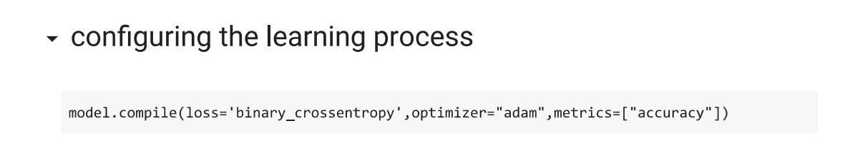

**TRAINING THE MODEL:**

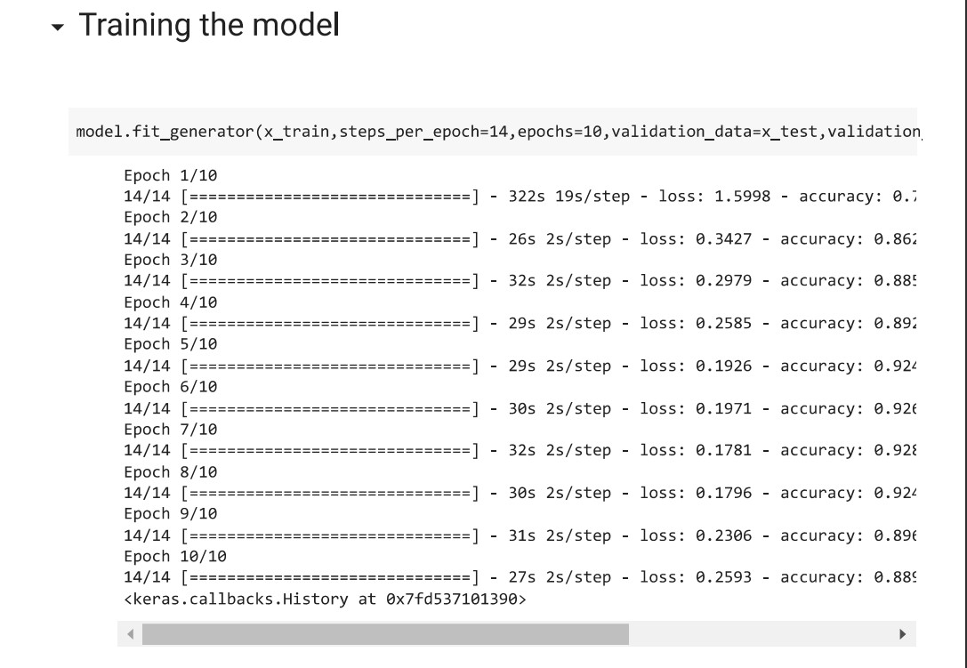

**SAVE THE MODEL:**

